MINISTRY OF EDUCATION AND SCIENCE OF UKRAINE

NATIONAL TECHNICAL UNIVERSITY   
“KHARKIV POLYTECHNIC INSTITUTE”

Department of Software Engineering and Management Information Technology

REPORT

on laboratory work # 1

on the discipline

“python frameworks”

Executed by

Student of the group KN-218g.e

Karyna OHOL

Checked by

Ass. Prof. of department “SEMIT”

Svitlana KOVALENKO

Kharkiv 2020

Jupyter Notebook Basics

**Goal:** Learning the specifics of using Python language in Jupyter Notebook.

Tasks

1. Install Anaconda.

2. Create environment for Python 3.

3. Change the Jupyter start-up folder.

4. Using the Markdown language and HTML tags for the country, according to the individual task (see Table 1), input information about the country’s area, its population, government, celebrities, cultural and natural attractions, and so on. When formatting information, following features:

˗ headings of different levels;

˗ bold, italics and underlines;

˗ different colors of symbols and background;

˗ borders;

˗ tables;

˗ nested lists;

˗ linked and embedded pictures;

˗ hyperlinks;

˗ the HTML tag to draw the country’s flag.

5. Create a function to implement the algorithm, according to the individual task from Table. 1. For the created function implement 2-3 test cases in the cells of the Jupyter notebook. For all tasks, organize checking of the input values.

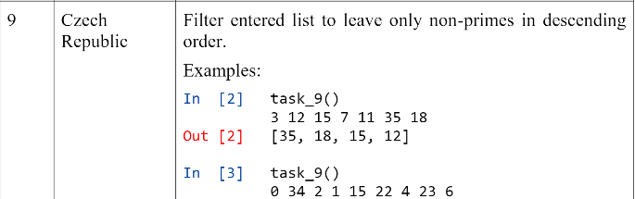

6. Post the created notebook on GitHub

**STEPS**

1 Installed and prepared Jupyter notebook (figure 1).

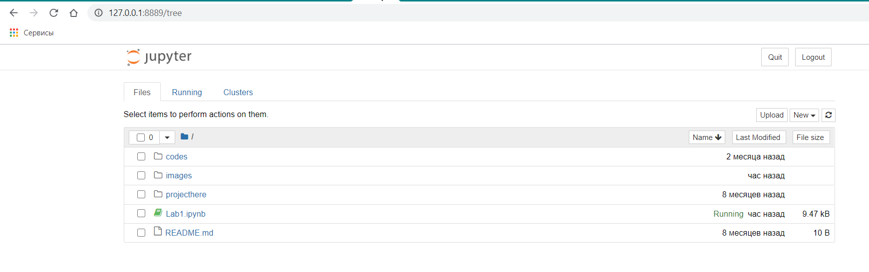

Figure 1 – Jupyter notebook main page

2 Creation HTML code in created notebook page (figure 2).

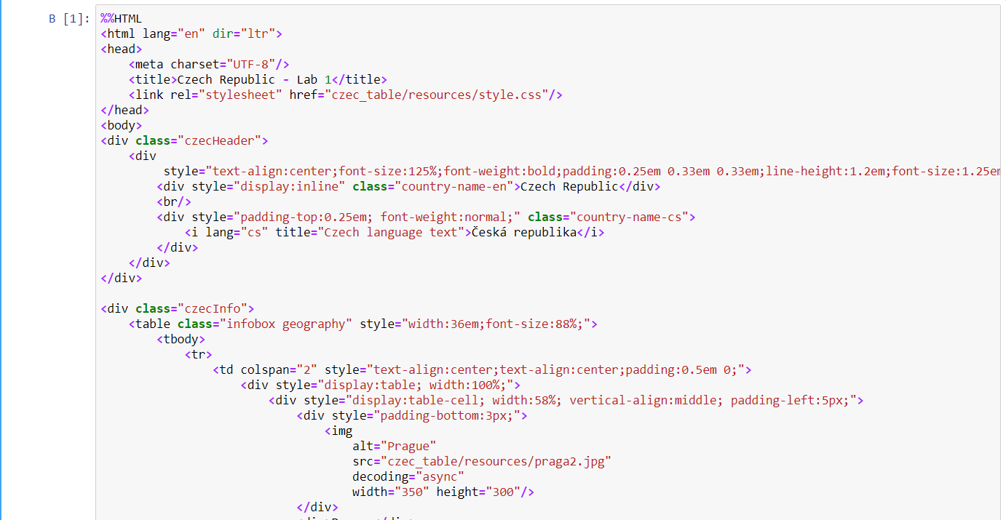

Figure 2 – Process of creation of the HTML code

3 Obtaining results if task 1 (figure 3).

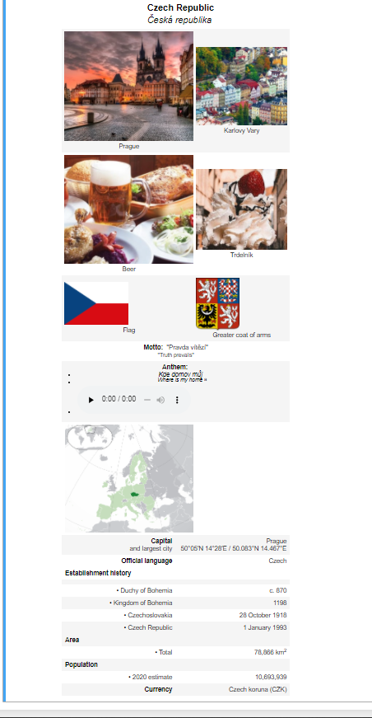

Figure 3 – Task 1 results

4 Creation of code for task 2 (figure 4).

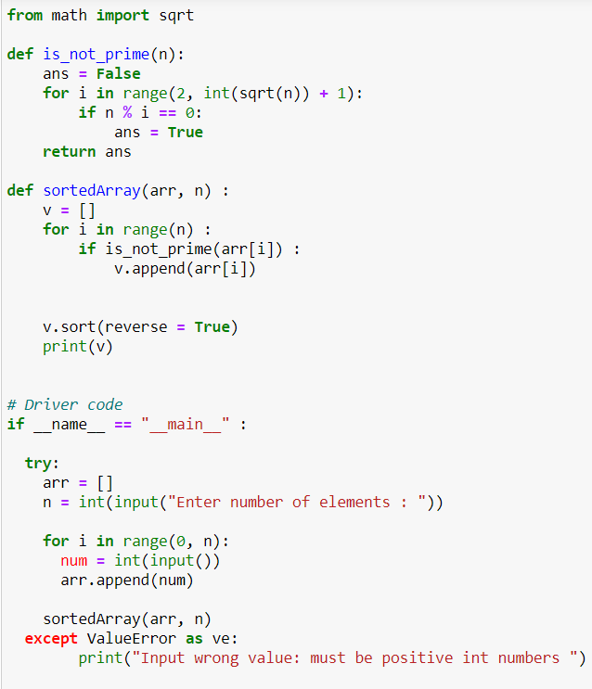

Figure 4 – Code for task 2

5 Tests of task 2 function (figure 5)

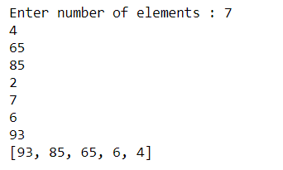

Figure 5 – Output of tests of task 2 functions

6 Repository on GitHub - **https://github.com/KarynaOhol/Pythonframework-.git**

**Сonclusions**

Some features of Jupyter notebook were studied and implemented during this laboratory training. Student got familiar with setting up notebook page, usage of different syntaxes in this page and creation of functions using Python programming language. Implementing of HTML page was quite hard due to the fact that student don’t know HTML language. However, student got fascinated with possibilities to insert several syntaxes in one notebook page. Moreover, notebook page has very convenient feature to split and run code in modules. Using that feature simplifies debugging and allows to see intermediate results of developing task.